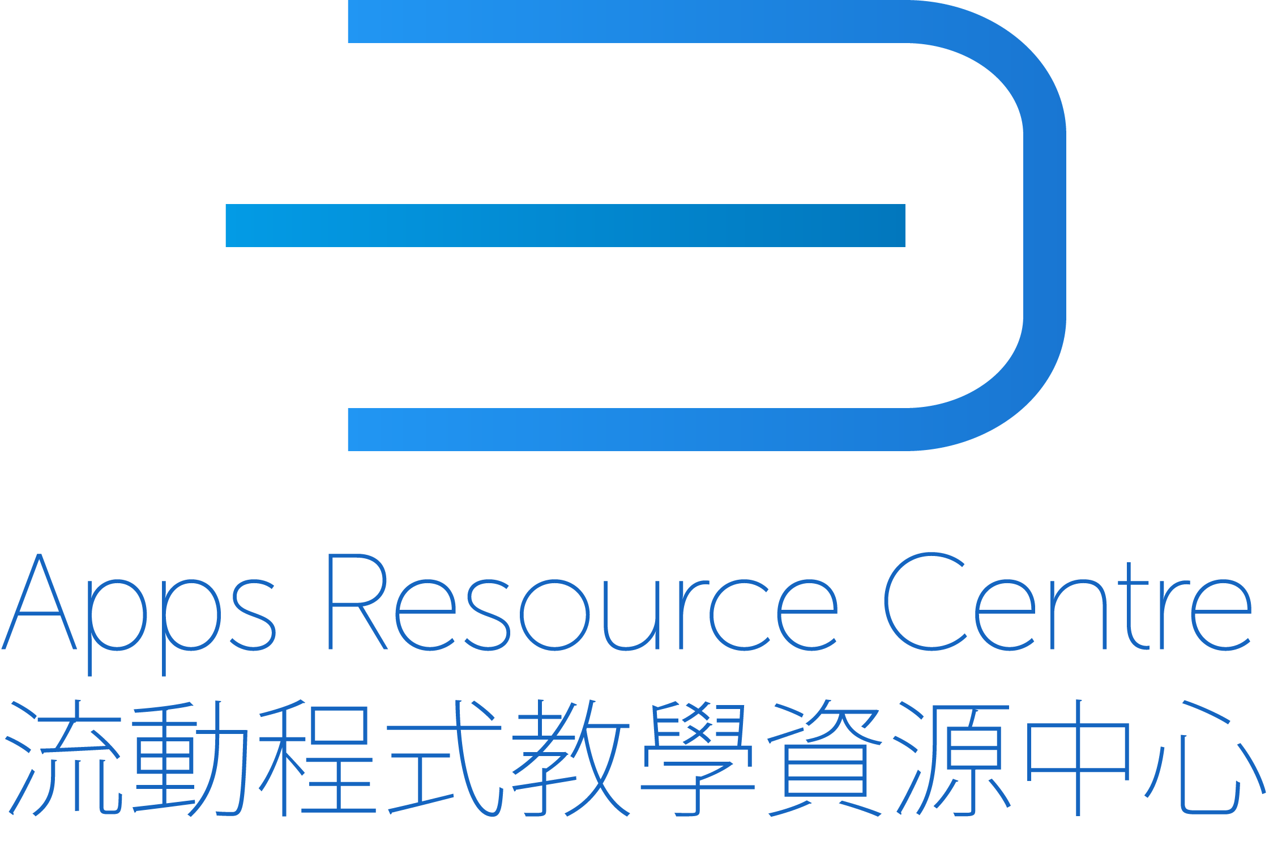

APPS RESOURCE CENTRE PROJECT PROPOSAL FORM

- Project title

- Name(s) of applicant(s)

NAME(S) | UGC FUNDED AFFILIATED UNIVERSITY

- Pedagogical problems to be addressed

- Target audience expected to use the App

TARGET UGC FUNDED STUDENT GROUP | EXPECTED NUMBER OF STUDENTS

- Potential users
WITHIN UGC | OUTSIDE UGC

- Proposed methodology for evaluating the app

- Resources available for App Design and Development

HUMAN RESOURCES | FINANCIAL RESOURCES

- Estimated date and time of deploying the App

ESTIMATED DATE

- Project Summary

Guidelines

- Please note that we strongly encourage a preliminary meeting and dialog with our team concerning the idea for your app and the feasibility of developing one before submitting this proposal form.

- After it has been submitted, our team will meet and discuss your proposal’s design, coding, and other resource requirements to assess its feasibility for us to develop.

- We have limited resources, and you should be aware that certain app functionalities can require very large development teams working for extended periods running into millions of dollars in development costs, which are beyond our current capacity.

- When possibly allocating our resources toward your proposed project, we need to consider the resources required, including existing code libraries, if the apps is similar to one for which we have already developed (cutting the development time), the app’s potential impact (how many students would benefit over how many years), and the value added-ness of developing an app versus a website or other platform.

- We also need to consider whether the proposed app largely duplicates existing and robust platforms, such as Google Docs, classroom management systems (e.g. Moodle), student response systems (e.g. Socrative), Facebook, and other platforms that would not be feasible or cost-effective for us to duplicate.

- Lastly, we need to consider our current workload and previous commitments.

